Import Data:

● Import “List of Orders.csv” into Power BI.

● Open “List of Orders” in Power Query Editor by clicking on ‘Transform’.

● Import “Order Details.csv” and “Sales target.csv” into Power Query Editor.

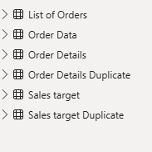

Data Transformation:

● Restrict the "List of Orders" table to only the first 500 rows.

* Ensure the “Order Date” column in the “List of Orders” table is set to data type 'Date'.
* Format the "CustomerName" column into proper case, ensuring consistent capitalization for each word.
* Merge the "State" and "City" columns to create a new column named "Location" in
* the format ‘City, State’.

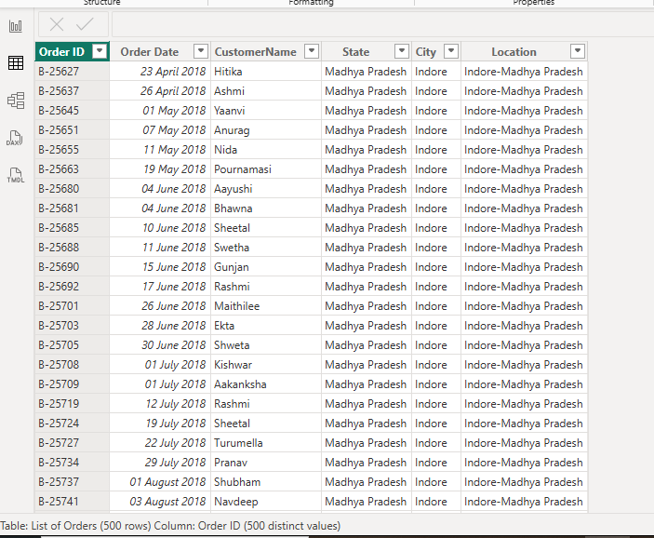

Change the data type of “Amount” and “Target” columns to ‘Fixed Decimal Number’.

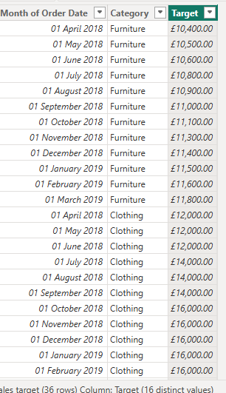

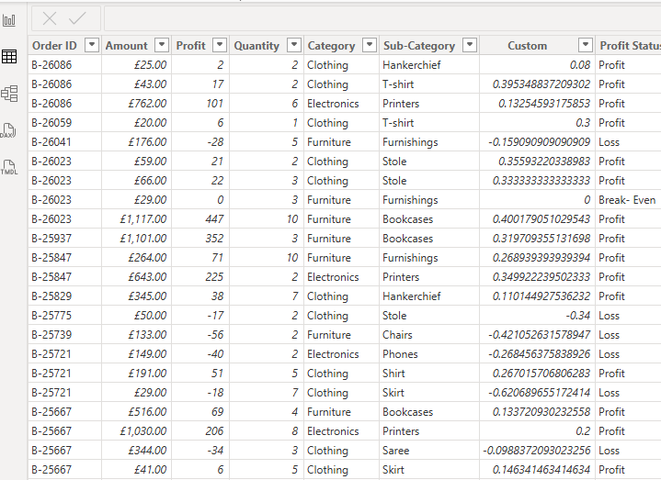

* Create a new custom column named "Profit Margin" as the percentage of "Profit"

divided by "Amount".

* Add a new conditional column named "Profit Status" based on the values in the

"Profit" column. The conditions are as follows: if the profit is less than 0, the label

should be "Loss"; if the profit equals 0, the label should be "Break-Even"; and if the

profit is greater than 0, the label should be

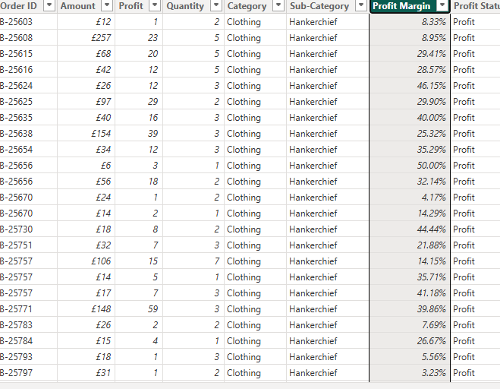

* Merge the "List of Orders" and "Order Details" tables into a new single table named "Orders Data" based on the "Order ID" relationship.

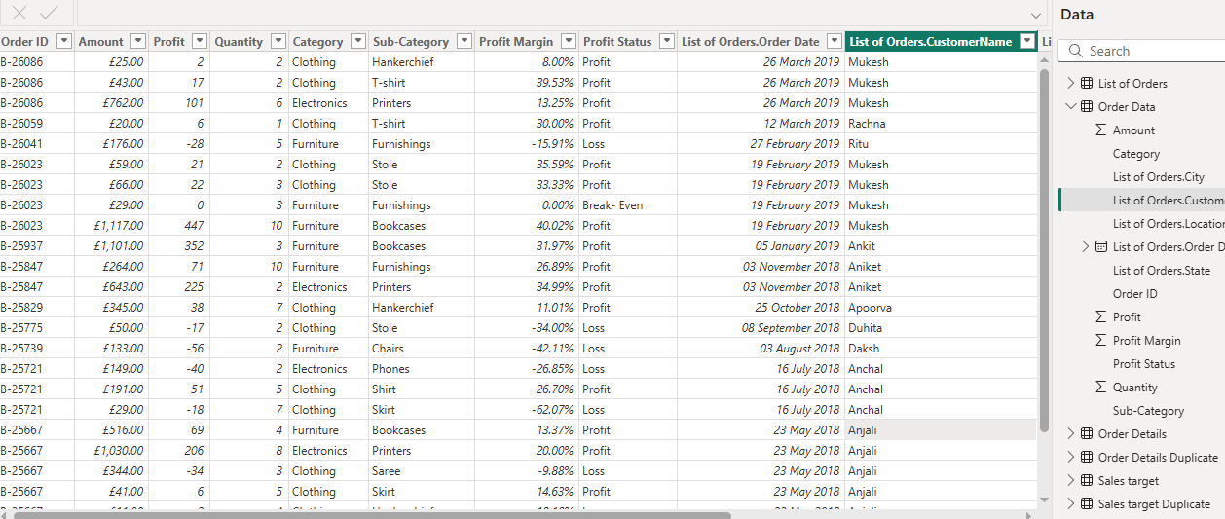

In the ‘Orders Data’ table, utilize sorting and filtering techniques on columns like

Order Date, State or Category to analyze data based on specific criteria:

◆ Sort the orders by Order Date in descending order to analyze recent trends.

◆ Filter the orders to focus only on a specific state (e.g., Tamil Nadu) for

regional analysis.

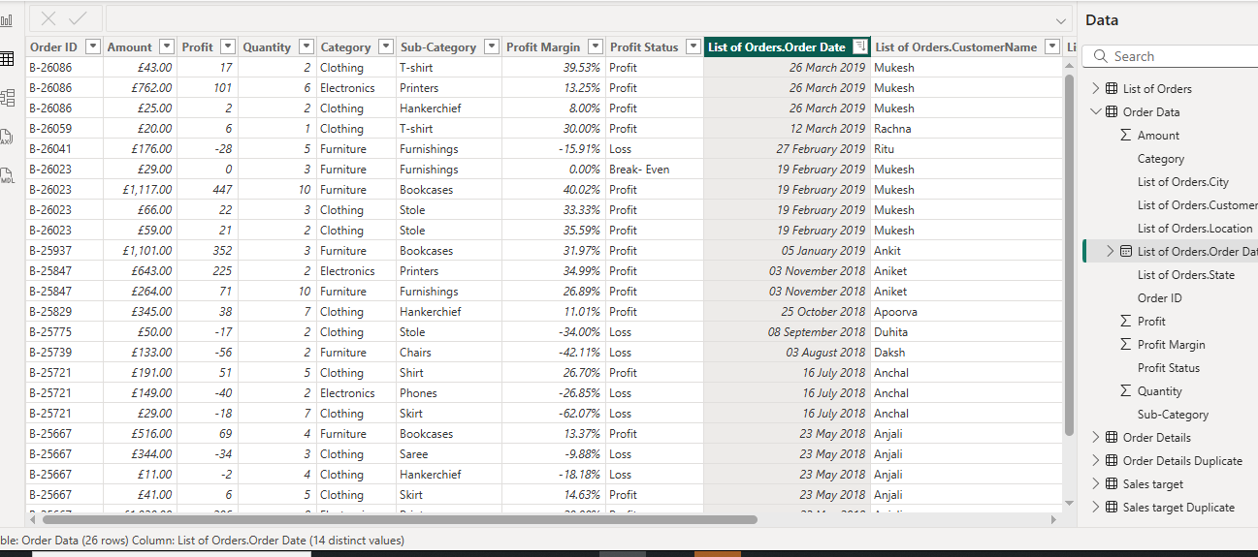

Grouping and Aggregating Data:

● Duplicate the “Order Details” table and calculate the count of each Order ID, average

profit by Category or total amount by Sub-Category.

● Duplicate the “Sales Target” table and aggregate the total target amount by Month of

Order Date.

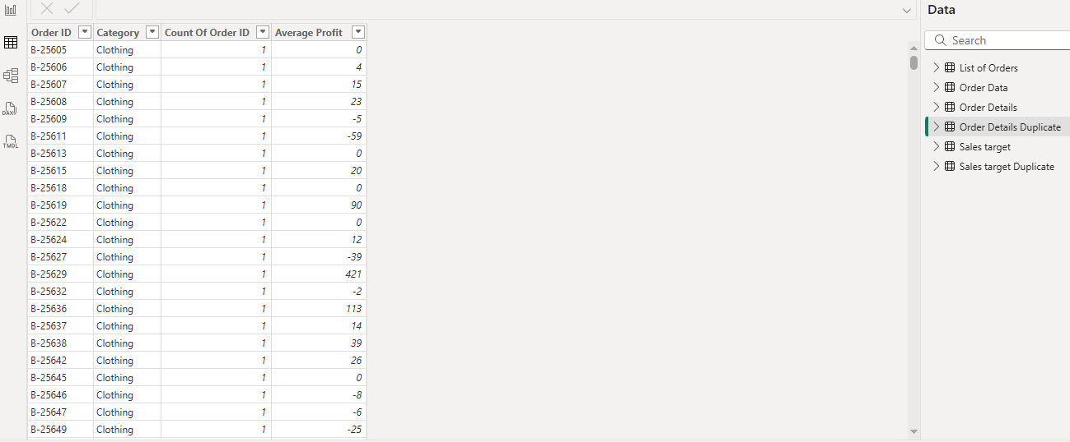

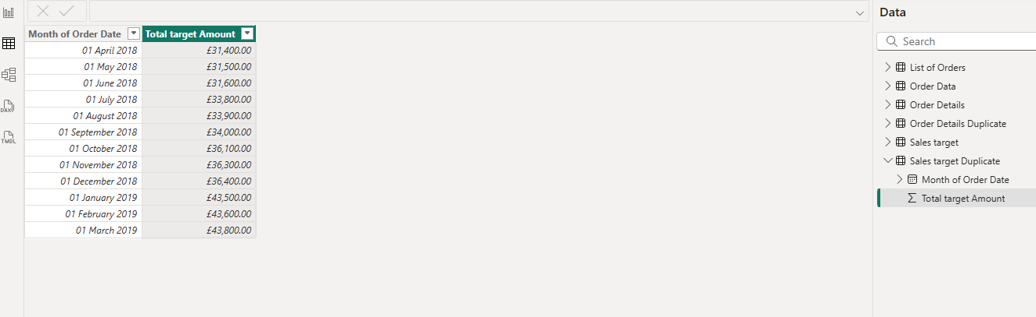

Data Modeling:

● Establish a relationship between the “List of Orders” and “Order Details” tables using

the ‘Order ID’ column.

● Build a relationship between the “Order Details” and “Sales Target” tables based on

the ‘Category’ column. Click "Manage relationships" and ensure this relationship is

active.

